Impressions of the General Assembly of the Church of Scotland (Part 1)
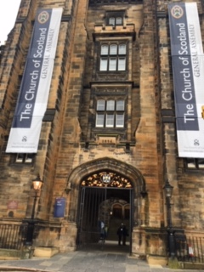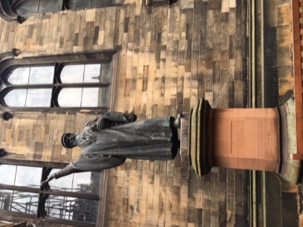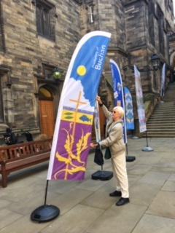
Saturday 18th May – Friday 24th May 2019.
Introduction
The General Assembly Hall of the Church of Scotland, sits imposingly on the mound, overlooking the National Gallery and Princess Street and was also previously home to the Scottish Parliament. Long furled banners proclaiming Church of Scotland hung on two imposing towers on either side of ornate doors leading into a central courtyard dominated by a huge statue of John Knox, alongside which the banners of various Presbyteries proudly stood, including Buchan. A series of steps at the end of this courtyard led up to two double doors, the main entrance into the Assembly Halls.
On the day before the Assembly started, new Commissioners (representatives from churches) were given a tour of the building. Instructions on where to collect our mail, how the voting system worked and procedures for asking questions or commenting on amendments were explained. This is testament to the inclusiveness of the Assembly in that anyone has the right to ask questions on the various reports we had received in advance, or make their views heard. This induction session went a long way to alleviate any anxiety I may have felt as a new comer.
The Opening Ceremony
The official General Assembly started on the Saturday 18th May amid great pomp and fanfare which was both a privilege and joy to be a part of but no photographs were allowed inside the chamber. The person seated next to me, realising I was a new comer, explained the significance behind the protocol of this ceremony and who was on the platform. This generosity of spirit and helpfulness was evident during the entire week as people went out of their way to be helpful and supportive, in many different ways. The Assembly chamber had seating on three sides facing a raised platform on which was the top table for the Moderator and Chief Clerk the Rev George Whyte (one of the Queen’s Chaplains) plus clerks and the Lord Procurator Fiscal, Mrs Laura Dunlop Q.C. Lord Provosts from all over Scotland also sat in the chamber for this ceremony. Previous Moderators titled Very Reverend, entered in order of seniority as well as the outgoing Moderator the Right Reverend Susan Brown BD Dip Min. The incoming Moderator the Reverend Colin Sinclair BA BD, entered last to music and fanfare.
Above this, was the public gallery in the centre of which was a very ornate chair with a raised dais above it, on which the Queen’s cousin, His Grace Richard Douglas Scott the Duke of Buccleuch and

Queensbury KT KBE Lord High Commissioner to the General Assembly, sat for his second year in office. He was `preceded by his Enquiry and the Grand Mace Bearer then afterwards by the Queen’s Archers who were dressed in brightly coloured livery. Invited members of the public (including ladies in hats) and armed forces, also sat in the public gallery and these personnel changed daily. The First Minister of Scotland Nicola Sturgeon, sat next to the Queen’s representative and she gave a speech to the Assembly on the Tuesday morning.
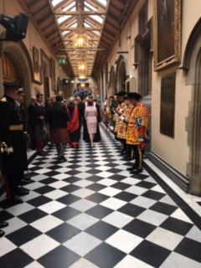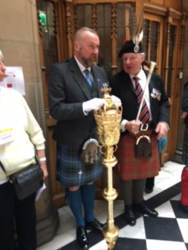
The Reverend Colin Sinclair then took the chair as Moderator after publicly accepting the post and the Prayer of Consecration. Her Majesty the Queen’s letter to the Assembly was read after which His Grace the Lord High Commissioner addressed the Assembly and a committee was formed to prepare a reply. (This was later read to the Assembly on Tuesday). The Standing Orders of the General Assembly were then presented and a communion service approved for the following day. The Moderator welcomed and presented visitors from various denominations to the Assembly two of whom gave speeches plus the President of the Scottish Bible Society.
Reports from Committees
The Assembly then got down to the nuts and bolts of approving reports compiled by the various committees. Each Committee Chair read out a summary of their full report then submitted the report to the Assembly for its approval. In all cases there were questions, amendments and often votes taken for final motions to be passed. It would be unrealistic to highlight all the reports in this article so the main ones relating to our congregation are shown below.
The Legal Questions Committee must provide a national framework to follow and keep church laws up to date and adapt old ones. It was agreed to pass legislation whereby Kirk Sessions have the option of appointing elders for fixed term periods. By this, Elders do not have to sit on the Kirk Session for life but can utilise their talents in other ways in church service as Elders. It was accepted that all of the 19 Presbyteries should participate in reviews undertaken by other Presbyteries to make them be more forward looking. (To date Buchan Presbytery has not undertaken this).
Special Commission on Structural Reform
The Rev. Professor David Fergusson headed this commission to independently review the standards of church governance to ensure they are fit for purpose to lead reform at a time when change is needed. He also consulted closely with the work of the Radical Action Plan Committee. He stressed how the General Assembly needed to be streamlined and updated and recommended that the Council of Assembly and its committees be replaced by 12 Assembly Trustees to be appointed for a 1-3-year term who in turn select a Convenor and Vice Convenor and an Administrative Trustee. They appoint a Senior Management Team who oversee Committees and Councils and select a Chief Officer and this was approved.
It was further agreed that by 2020 The Assembly Trustees compile a report providing recommendations to reduce administrative costs by 20%- 30%, by reducing staffing and conducting a pay scale review as well as ways in which the Social Care Council and Crossreach can become more self -sustaining and financially viable organisations in their own right. In addition, they have to ensure adequate funds are available for research and analysis to further enhance the work of the church. They too must reduce the number of Presbyteries significantly within 5 years to 12 and empowerment be given to the church at local level. It was approved to merge the Ministries Council with the Mission and Discipleship Council and The Church and Society Council with the World Mission Council by the end of 2019 as well as The Mission and Discipleship Committee having to organise Heart and Soul 2020.
He further recommended a Business Committee be set up with a Convenor and Vice Convenor to ensure all structural reform is being carried out covering governance, finance, structural, staffing and streamlining of the General Assembly. Their task also is to prepare plans for the 2020 General Assembly in light of these issues and they must work with the Principal Clerk. They take over the responsibility for all properties, rights, assets and functions of the Assembly Arrangements Committee, as well as trust funds, donations and legacies.

Council of Assembly /Radical Action Plan
In the past the church was set up for larger congregations with the emphasis not just on religion but pastoral, educational and mission work too. It is now being hampered by this outdated system. The Church Without Walls recommendations 20 years ago were never fully implemented in terms of structural change and realignment of resources. Thus, much of the wonderful work being done was despite our systems and structures and not because of them. The Radical Action Plan seeks to reverse this.
The church is running at a substantial annual deficit and consequently reducing its reserves and this committee was set up under its Convenor Dr Sally Bonner - to review the churches finances and budget allocation due to the deficit, which it is hoped will be reduced to 2.9 million by 2020 as well as the possible selling off of the Assembly Hall, which will be reported back in 2020. In addition, 60 funds have been reorganised as well as loans, in efforts to streamline and make savings. Approval was given for a growth fund of £20-£25 Million for the period 2020-2026 to support the numerical and spiritual growth of existing Church of Scotland congregations worshipping communities, community transformation and tackling poverty. In addition, it was approved to refocus the National Office Support Team to enable, equip and support local churches as well as giving them access to this fund.
Further approvals were received for the establishment of the 12 regional Presbyteries by 2024 or sooner. In relation to our churches, it was agreed to compile legislation by 2020 to enable the establishment of networks, hubs and other forms of local churches and encourage cooperation amongst churches, as well as the review of size and responsibilities of the Kirk Sessions. Vacancy allowances are to be reviewed from being under church control and instead passed to Presbytery and new ways are to be developed to support congregations with long term vacancies. Further measures passed included training and support for congregations, as well as leadership and initiatives for the engagement of those under 40 years of age.
It was agreed to review whether proceeds from redundant buildings could, in certain circumstances, be passed to the congregation and support be given at local and regional level to congregations in relation to buildings, safeguarding, finance and accounting, staff employment and developing effective partnerships.
A further 10 Reports were given and approved by the Assembly during the course of the rest of the week.

Impressions From the General Assembly (Part 2)
The Social Side to Assembly
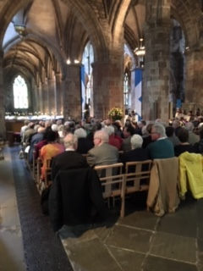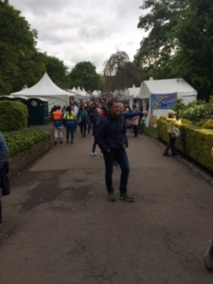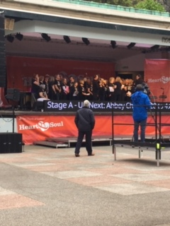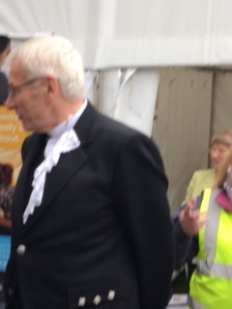

A most enjoyable aspect of the attending the Assembly was in meeting various people from all over the world in connection with the life and work of the church. Everyone was incredibly friendly and many opportunities presented themselves to engage in conversations with people during coffee and lunch breaks, plus there were daily programmes of talks one could attend on interesting topics during the lunch hour or in the evenings.
I attended the Sunday morning service in St Giles Cathedral and it was wonderful to be in a packed- out church despite the pillars posing a visual block to proceedings. Leaving there, I proceeded to Princess Street Gardens for the Heart and Soul gathering. Lots of small tents (75) lined the pathway on both sides with exhibitors all advertising some aspect of the churches work e.g. Cross Reach, Iona Community, Guild, Street Pastors, Ross Presbytery etc, as well as two main stages including one for children and a bandstand. Entertainment went on continuously throughout the afternoon and my favourite was the Abbey Gospel Choir from North Berwick. A communal service for was taken at 5.00p.m on the main stage, then the event finished at 6.00p.m. A highlight was the walk about of the Moderator the Right Rev Colin Sinclair who was happy to pose for photographs and selfies.
I had volunteered to help with the Communion at the General Assembly on the Monday and we had been given a rehearsal at the close of sessions on the Saturday. It was done to a very stylised and traditional sequence where one had to work in sync with a partner who entered from the opposite side of the Assembly Hall to me. I had to serve real port wine from two massive silver goblets dating back to 1840 and of course worried about tripping up, but all went well. A further highlight was volunteering to sing in the choir on two occasions and we had rehearsals with a trained choir master beforehand, who was young and selected a lovely mixture of styles. The massed singing in the assembly hall was very moving, especially the psalms.

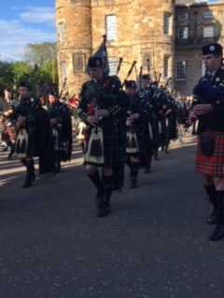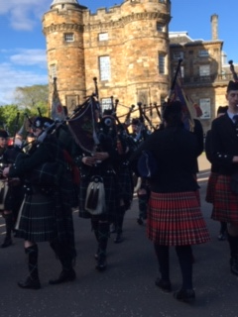
Another highlight was the invitation to the Beating of the Retreat at Holyrood Palace on Thursday evening. Fortunately, it was a beautiful sunny evening and a delight to watch massed bands of the Cadet Forces march up and down in the presence of His Grace the Duke of Buccleuch and other dignitaries. When this finished, we were invited to go inside the palace for a reception. It had a central lawn surrounded by buildings on each side with architecture similar to Versailles. Beautiful hanging baskets and floral arrangements complimented everywhere. We were shown to an upstairs long reception room full of paintings and then mixed with other guests and enjoyed wine and canapes.
Conclusion
This General Assembly was an experience never to be forgotten, due to its traditions, debate and the fact it made history due to the passing of the Radical Action Plan for reform. It certainly opened my eyes to the vast areas of wonderful work undertaken by the Church of Scotland and the amazing people who do it. I would recommend this event to anyone connected with the work of the Kirk.
Irene Finlayson
Elder Banff Parish Church
27/5/2019

